Output/Result:

Select manager address: 0x5c6B0f7Bf3E7ce046039Bd8FABdfD3f9F5021678.

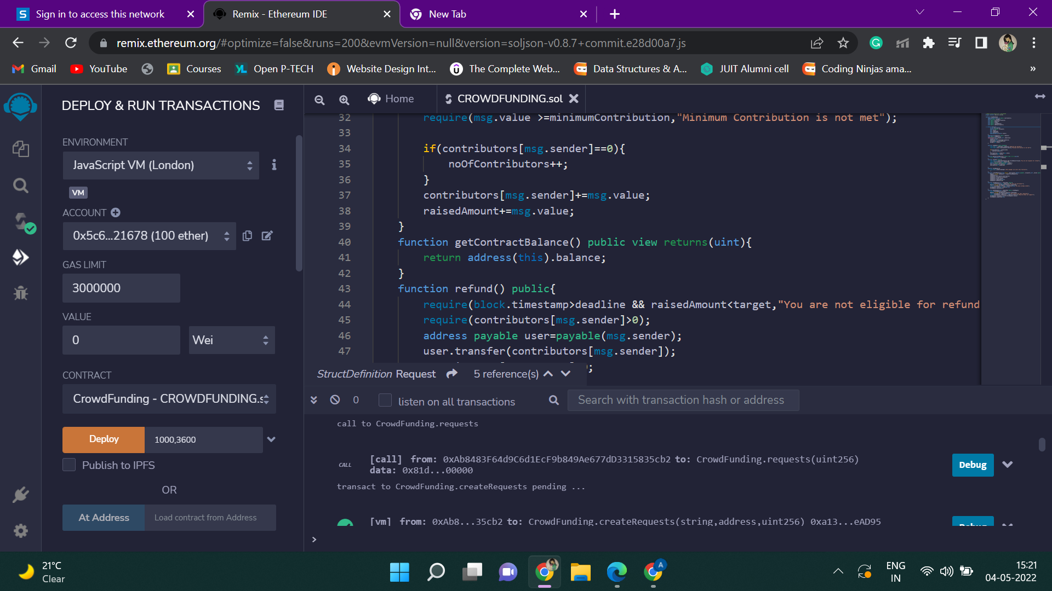

Set target value 1000 Wei and the deadline for 3600 seconds.

Deploy the smart contract.

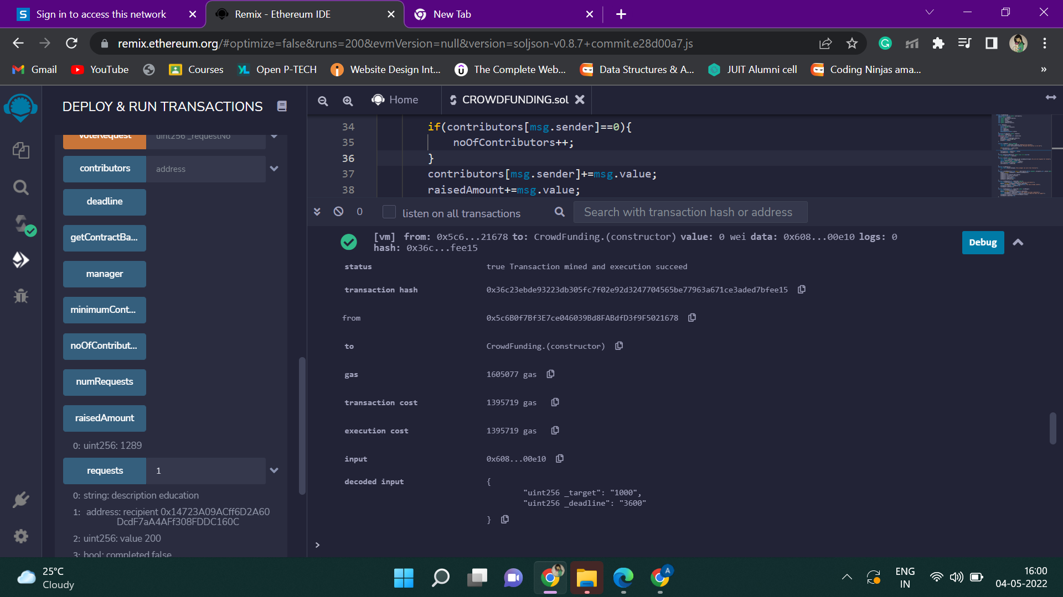

The contract has been deployed successfully using the Ropsten test network.

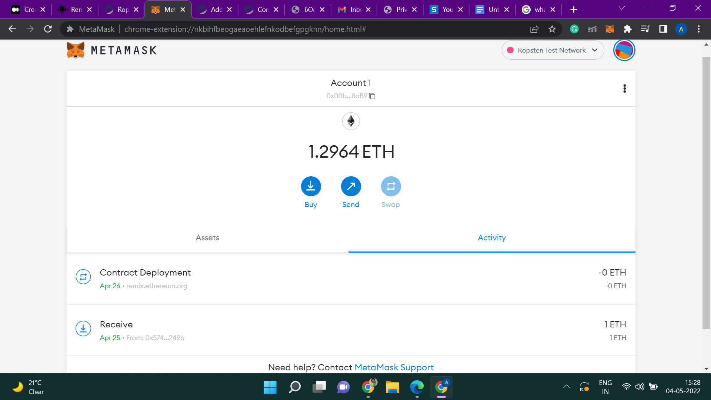

Transaction details can be seen from Etherscan, which is a block explorer and analytics platform that allows you to access details on any Ethereum blockchain transactions that are pending or confirmed.

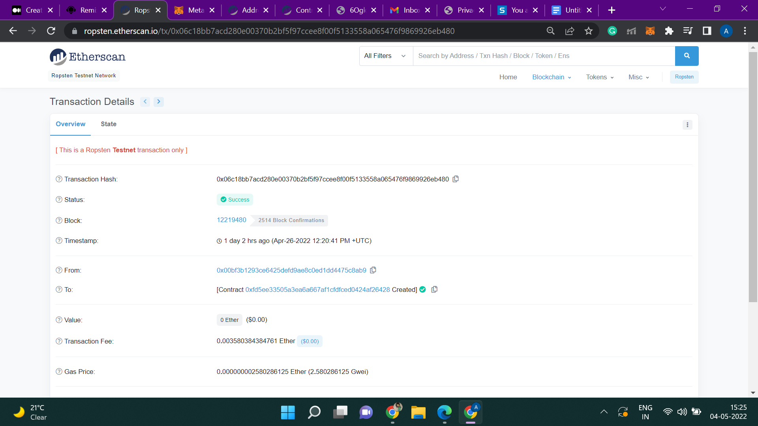

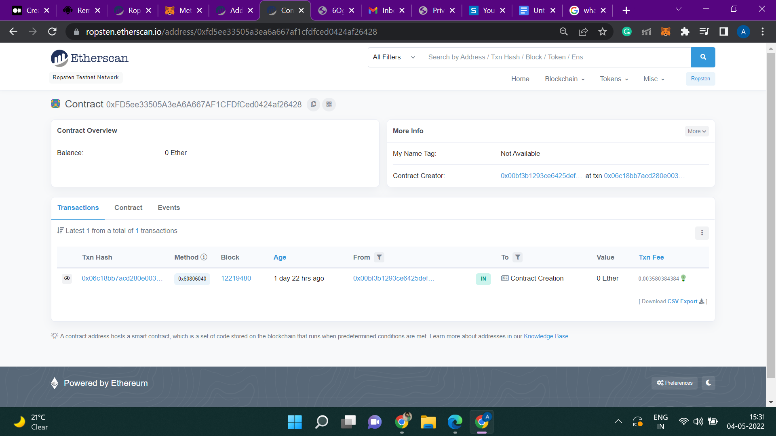

Suppose manager creates a request for environment issues with the following recipient address: 0xCA35b7d915458EF540aDe6068dFe2F44E8fa733c

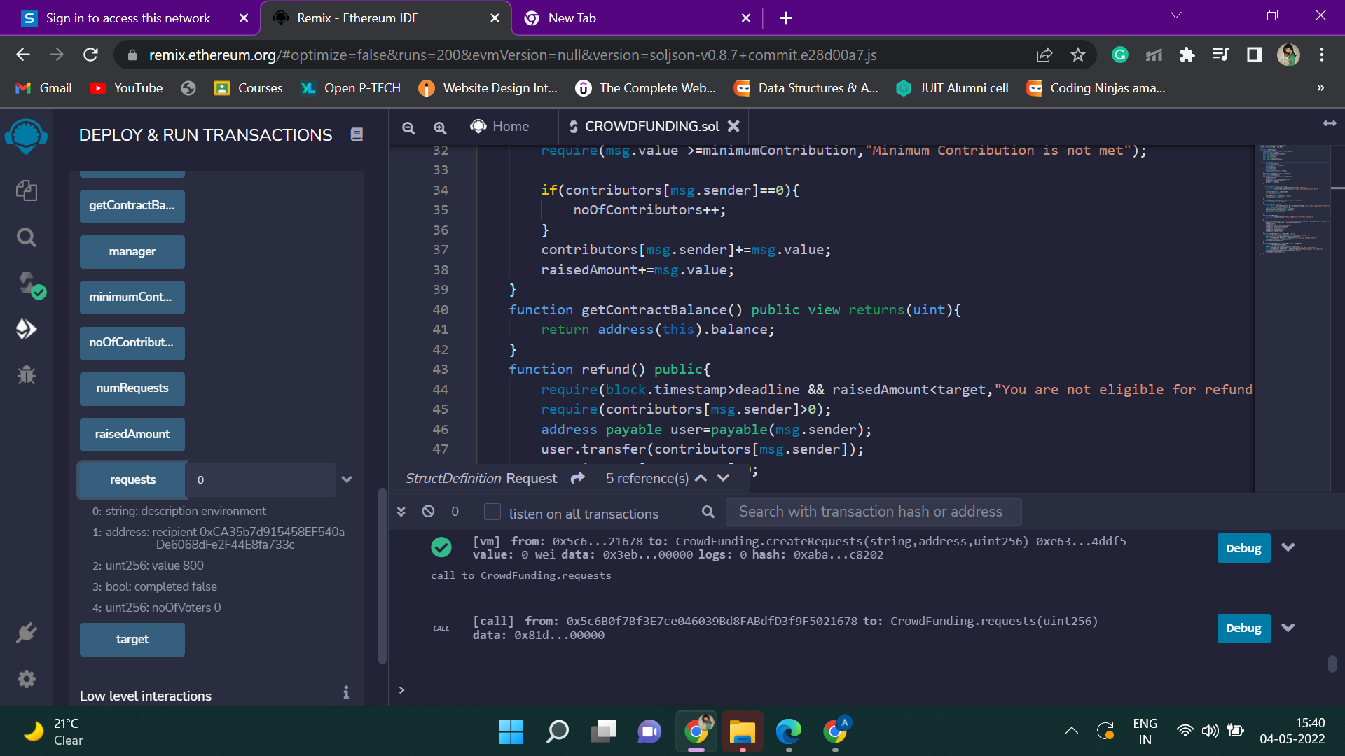

The request has been created.

Now manager will create another request for education with the following recipient address: 0x14723A09ACff6D2A60DcdF7aA4AFf308FDDC160C

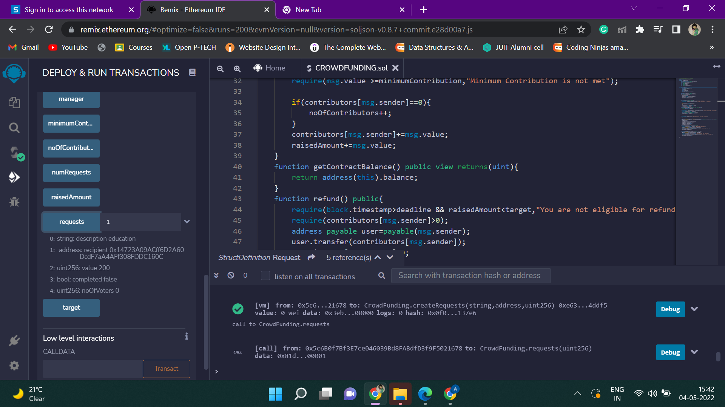

The request has been created.

Now let us take 3 contributors with the following addresses:

Contributor 1: 0x03C6FcED478cBbC9a4FAB34eF9f40767739D1Ff7

Contributor 2:0x1aE0EA34a72D944a8C7603FfB3eC30a6669E454C

Contributor 3: 0x0A098Eda01Ce92ff4A4CCb7A4fFFb5A43EBC70DC

Contributor1 contributes 600 Wei.

Contributor2 contributes 800 Wei.

Contributor3 contributes 200 Wei.

The total raised amount is shown here:

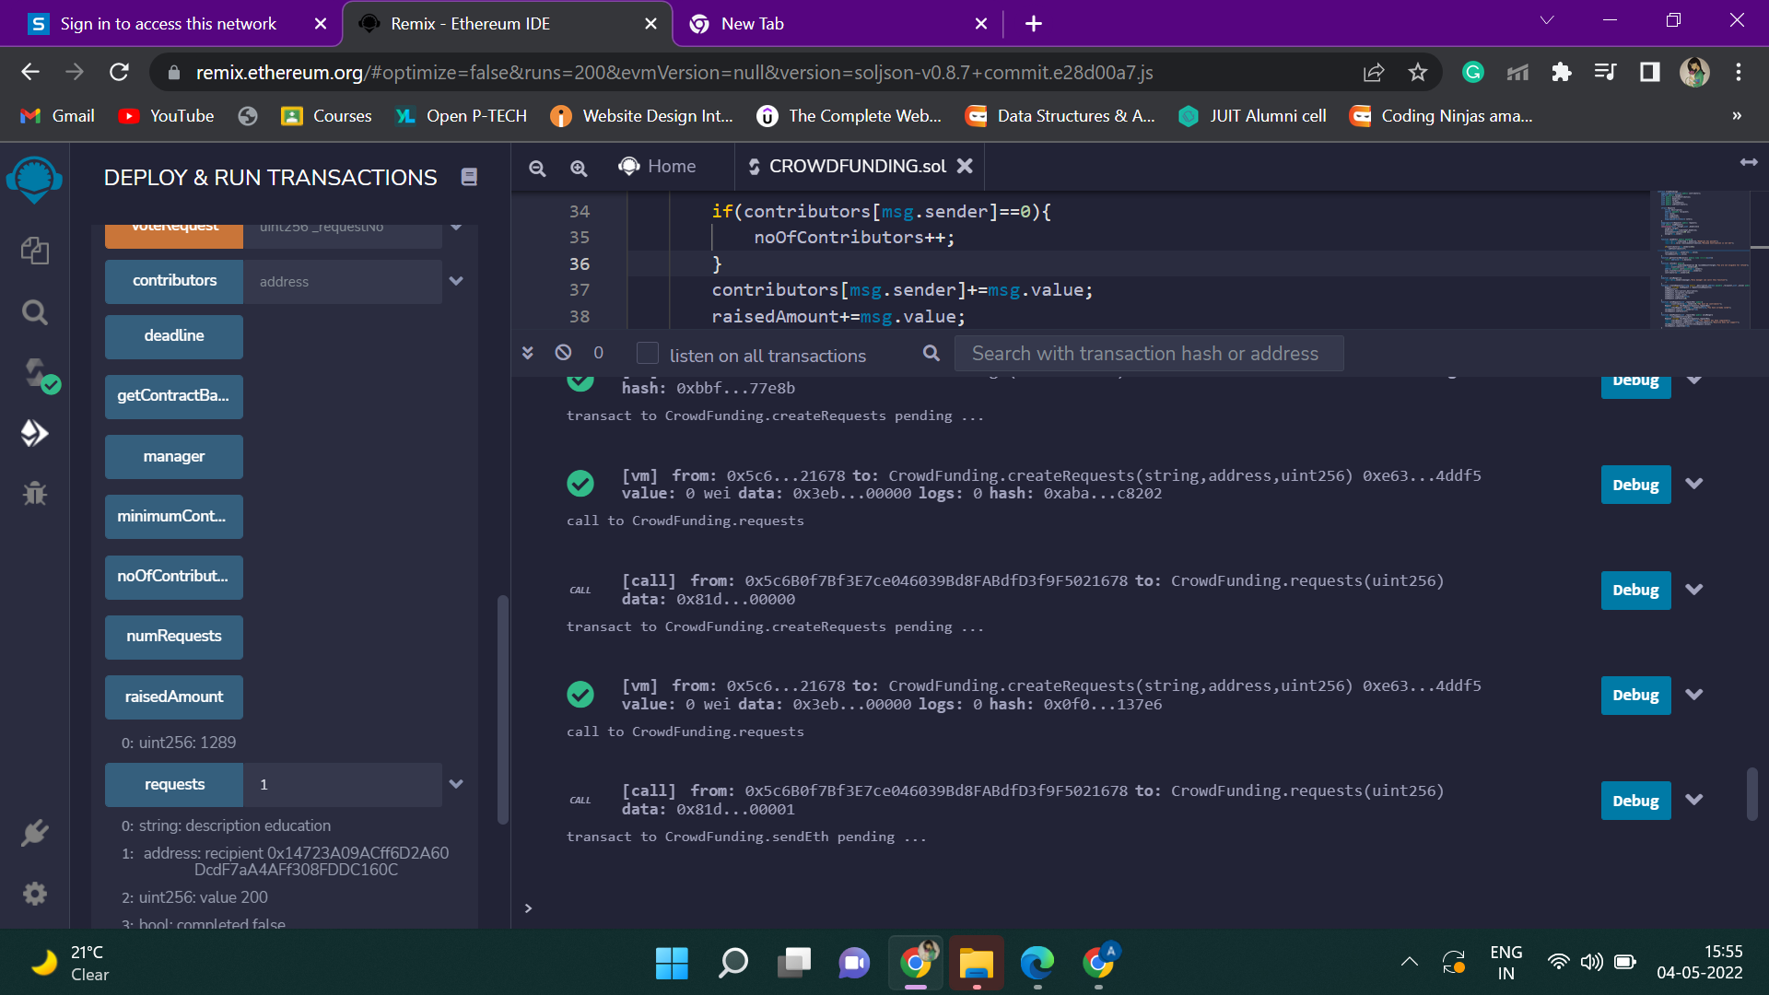

Transaction records are displayed here:

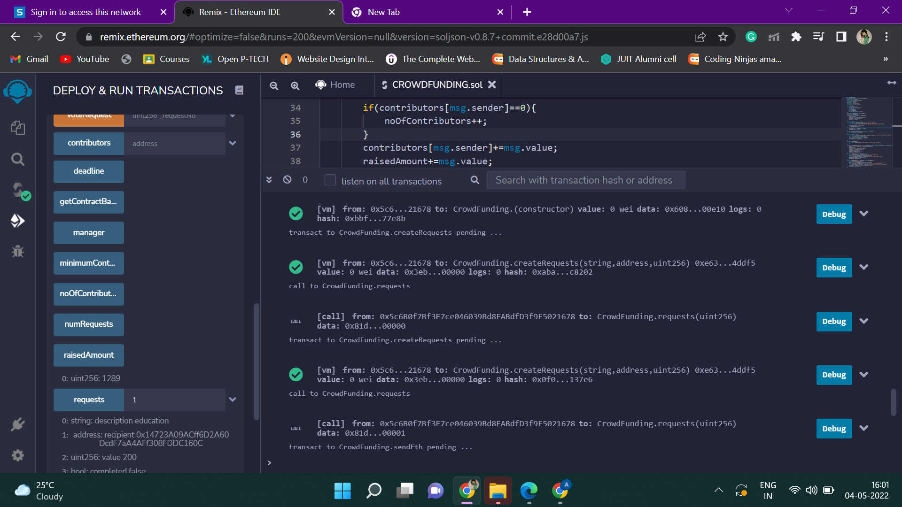

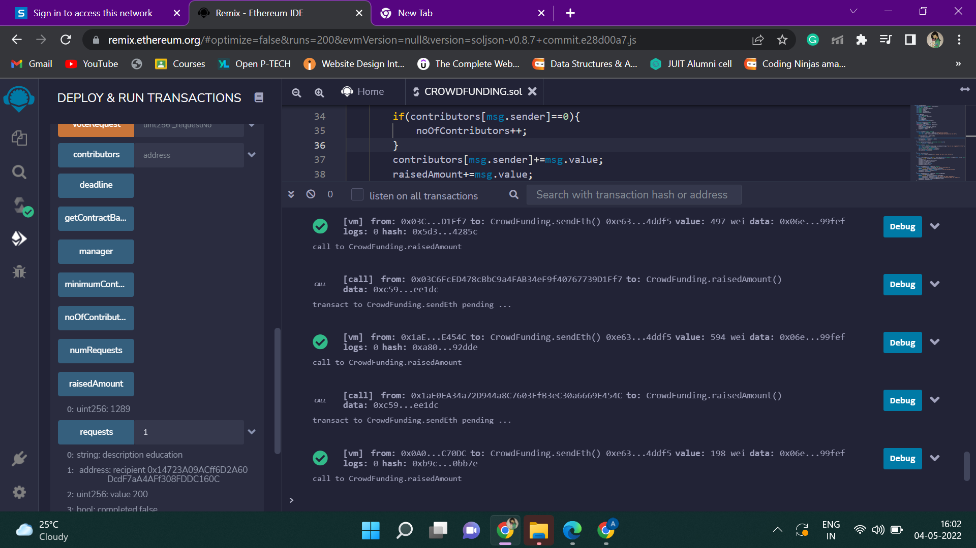

Now the contributors will vote for a particular request. If the number of votes will be more than 50%, then the manager will transfer the raised amount to the respective recipient.

Contributor1 and Contributor2 vote for “Environment” and Contributor3 vote for “Education”.

So the total number of votes for “Environment” will be = 2

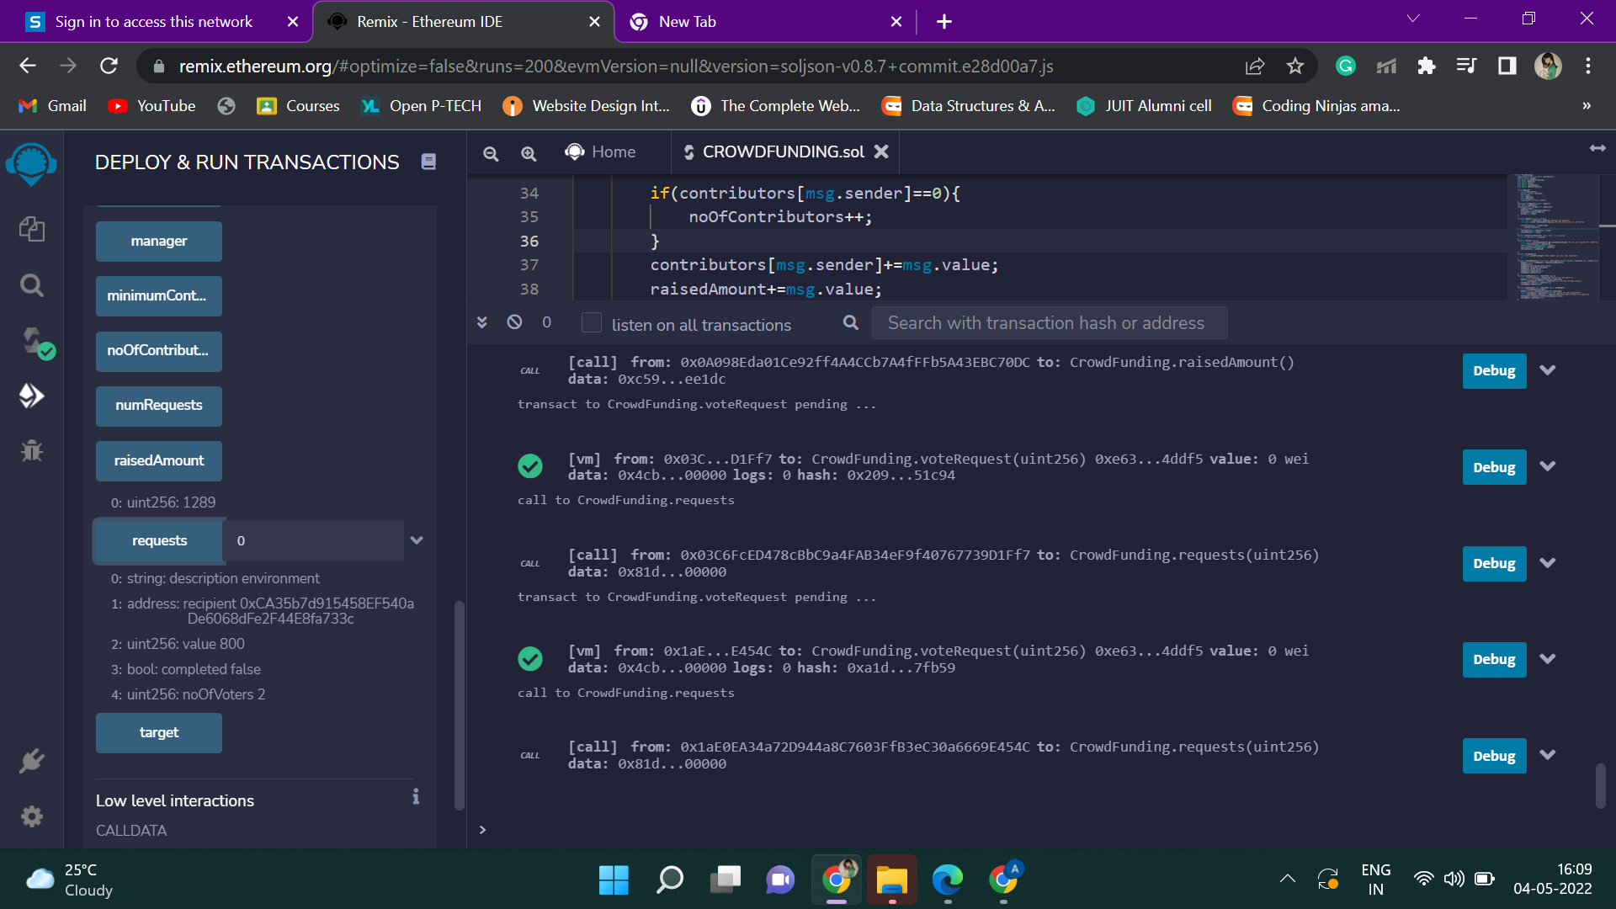

And, the total number of votes for “Education” will be = 1.

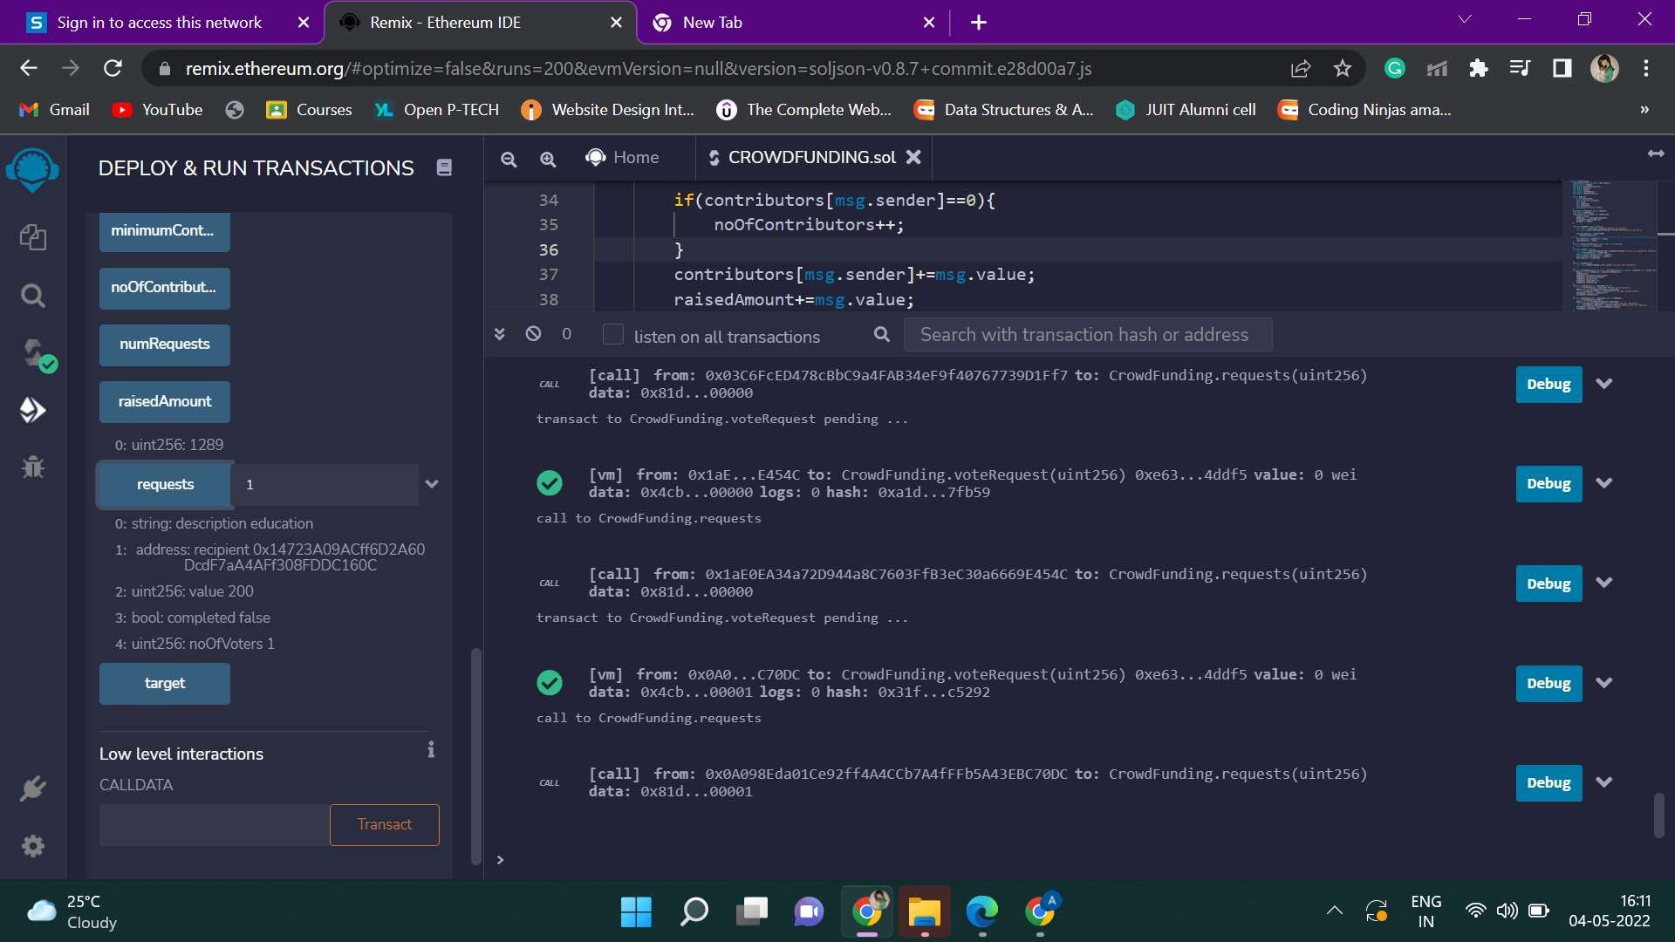

If the manager wants to make payment for “Education”, then an error message will popup as the majority did not support it.

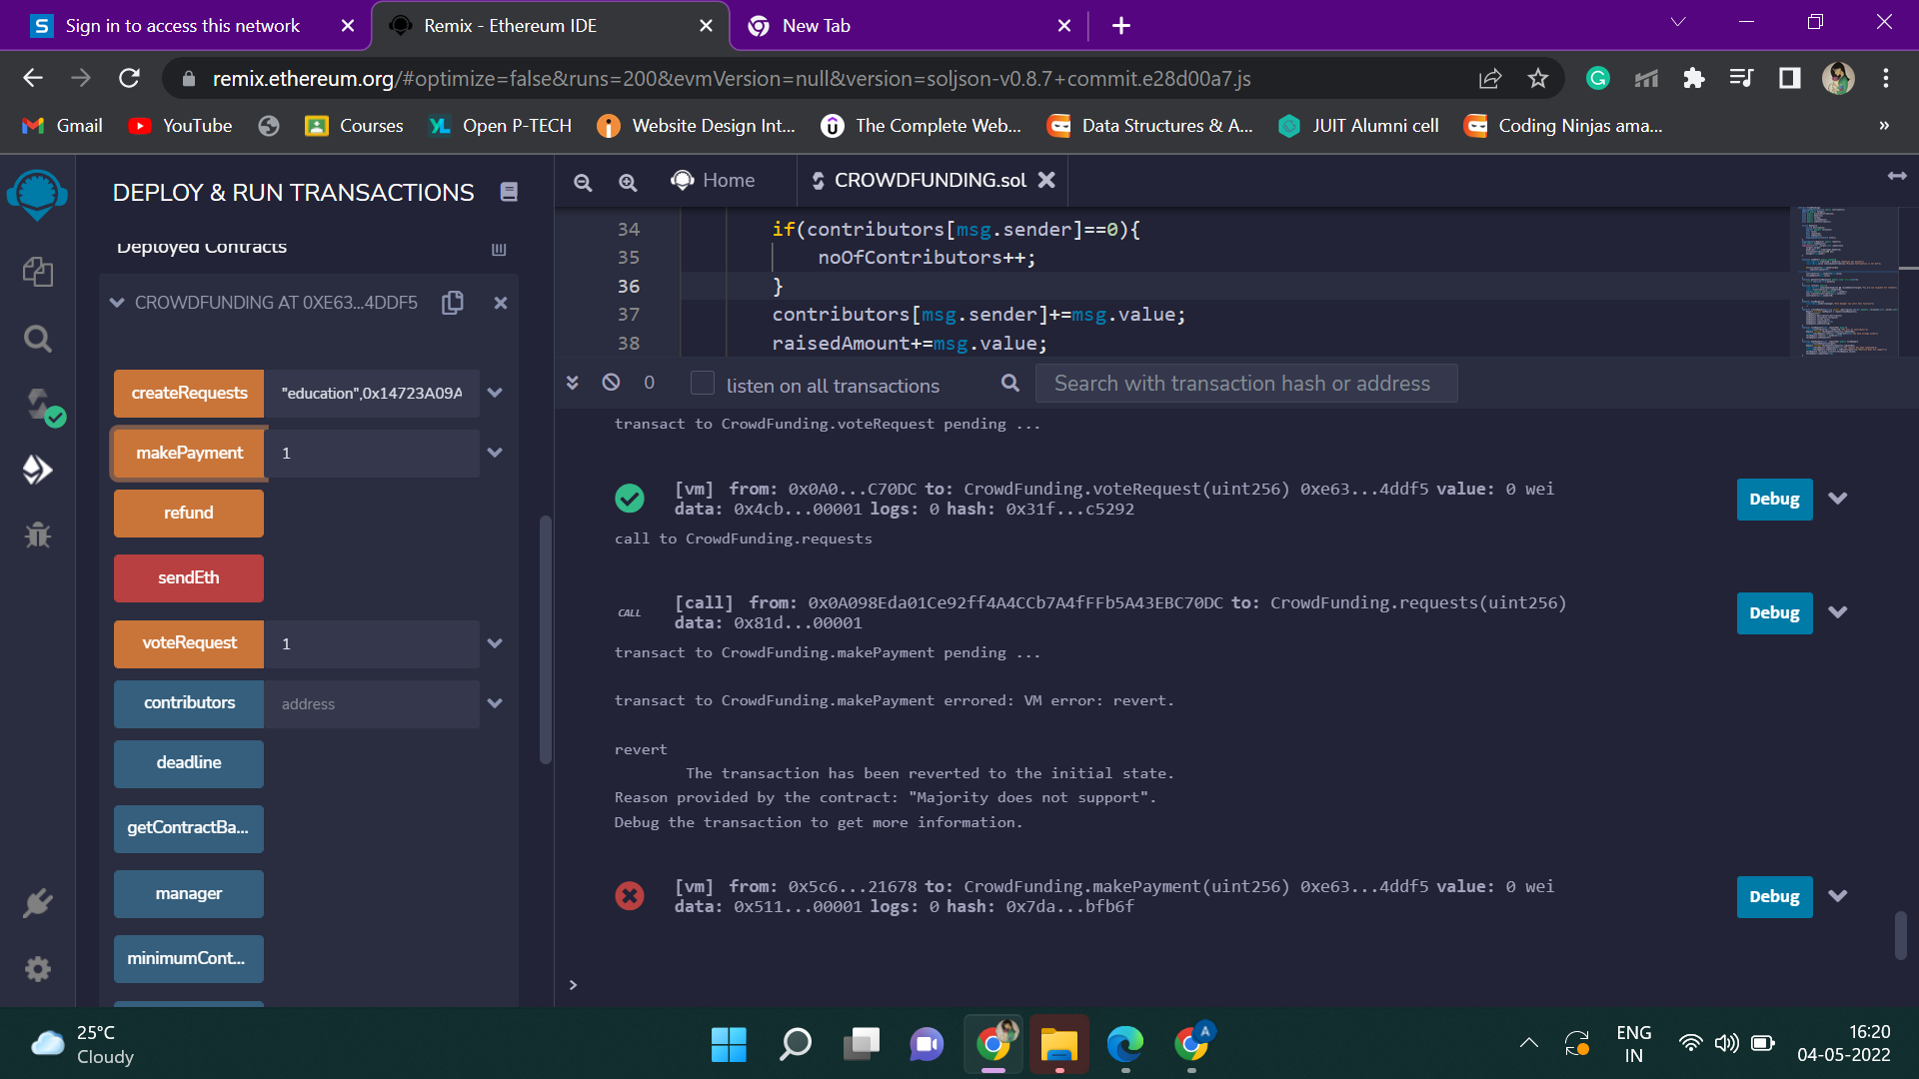

Now if the manager makes the payment for “Environment” which has majority of supporter, then the payment will be successful as shown.

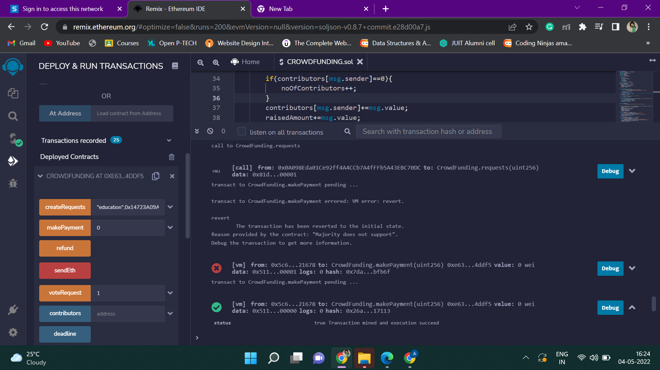

The recipient with address 0xCA35b7d915458EF540aDe6068dFe2F44E8fa733c now have received the payment.

